NAME: M.Venkata Veeranjaneya Reddy
REG NO:-192472140
COURSE CODE:-ITA0510;COMPUTER VISION
SLOT-A

Aim:To read an image in Python and perform erosion using the OpenCV erode() function.

Algorithm
- Import OpenCV and NumPy libraries.
- Read the input image.
- Create a kernel matrix.
- Apply cv2.erode() to the image.
- Display the original and eroded images.
CODE:
import cv2 import numpy as np from google.colab.patches import cv2_imshow img = cv2.imread(r"/content/images.png") kernel=np.ones((5,5),np.uint8) erode=cv2.erode(img,kernel,iterations=1) cv2_imshow(img) cv2_imshow(erode)


Result
The image was successfully read and erosion was performed. Small white regions were removed, and the object boundaries became thinner.

EXPERIMENT-6
Aim
To read a captured video and display it in slow motion and fast motion using OpenCV.

Algorithm
- Import OpenCV.
- Open the video using VideoCapture().
- Read each frame.
- Display the frames with different delay times using waitKey().
- Close the video after completion.
CODE:
import cv2 from google.colab.patches import cv2_imshow path = r"/content/istockphoto-2155009603-640_adpp_is.mp4" def play_video(delay, title):
cap = cv2.VideoCapture(path) print(title + " - Press q to continue") while True:
ret, frame = cap.read() if not ret: break
OUTPUT:
cv2_imshow(frame) if cv2.waitKey(delay) & 0xFF == ord('q'):

break cap.release()
# Call function for different speeds play_video(30, "Normal Speed") play_video(100, "Slow Motion") play_video(10, "Fast Motion")
RESULT- The program is executed successfully.

To capture video from a webcam and display it in slow motion and fast motion.

Algorithm
- Import OpenCV.
- Access the webcam using VideoCapture(0).
- Capture video frames continuously.
- Display frames using different delay values.
- Exit when a key is pressed.
CODE:
import cv2 from google.colab.patches import cv2_imshow path = r"/content/istockphoto-2155009603-640_adpp_is.mp4" def play_video(delay, title):
OUTPUT:
cap = cv2.VideoCapture(path) print(title + " - Press q to continue") while True:

ret, frame = cap.read() if not ret: break
cv2_imshow(frame) if cv2.waitKey(delay) & 0xFF == ord('q'):
break
play_video(30, "Normal Speed") play_video(100, "Slow Motion") play_video(10, "Fast Motion")

RESULT- The program is executed successfully.

To scale an image into bigger and smaller sizes using OpenCV.

Algorithm
- Read the input image.
- Use cv2.resize() with scale factors.
- Create enlarged and reduced images.
- Display all images.
CODE:
import cv2 from google.colab.patches import cv2_imshow Upload the image to Colab first image = cv2.imread("/content/images.png") if image is None:
print("Image not found!") else:
bigger = cv2.resize(image, None, fx=2, fy=2) smaller = cv2.resize(image, None, fx=0.5, fy=0.5) print("Original Image")
cv2_imshow(image) OUTPUT:
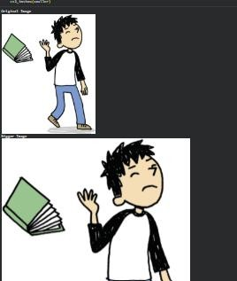
print("Bigger Image") cv2_imshow(bigger) print("Smaller Image") cv2_imshow(smaller)

RESULT- The program is executed successfully.
To rotate an image in clockwise and counter-clockwise directions.

Algorithm
- Read the image.
- Use cv2.rotate() for clockwise rotation.
- Use cv2.rotate() for counter-clockwise rotation.
- Display the rotated images.
CODE:
import cv2 from google.colab.patches import cv2_imshow image = cv2.imread("/content/images.png") if image is None:
print("Image not found!") else:
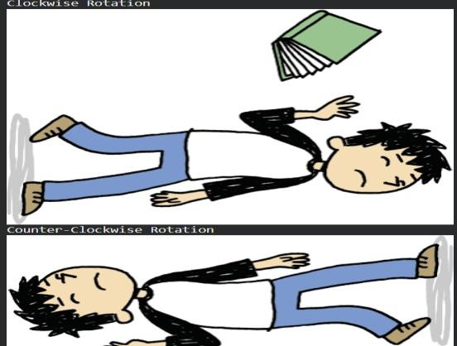
clockwise = cv2.rotate(image, cv2.ROTATE_90_CLOCKWISE) counter_clockwise = cv2.rotate(image, cv2.ROTATE_90_COUNTERCLOCKWISE)
OUTPUT:
print("Original Image") cv2_imshow(image) print("Clockwise Rotation") cv2_imshow(clockwise) print("Counter-Clockwise Rotation") cv2_imshow(counter_clockwise)

RESULT- The program is executed successfully.

To move an image from one position to another using translation.

Algorithm
- Read the image.
- Create a translation matrix.
- Apply cv2.warpAffine().
- Display the translated image.
CODE:
import cv2 import numpy as np from google.colab import files from google.colab.patches import cv2_imshow uploaded = files.upload() image = cv2.imread("sample.jpg") rows, cols = image.shape[:2]
M = np.float32([[1,0,100],
[0,1,50]])
move = cv2.warpAffine(image, M, (cols, rows)) print("Original")
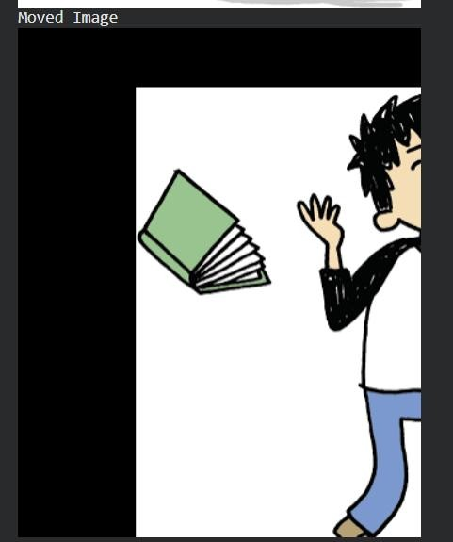
cv2_imshow(image) print("Moved") cv2_imshow(move)
OUTPUT:

RESULT- The program is executed successfully.

EXPERIMENT-11
Aim
To perform affine transformation on an image using OpenCV.

Algorithm
- Read the image.
- Select three source points.
- Select three destination points.
- Compute the affine transformation matrix.
- Apply cv2.warpAffine().
- Display the transformed image.
CODE:
OUTPUT:
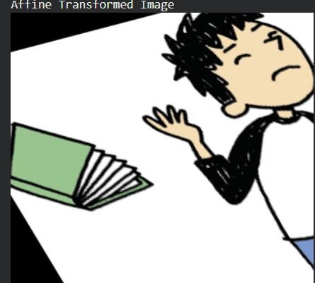
import cv2 import numpy as np from google.colab import files from google.colab.patches import cv2_imshow uploaded = files.upload() image = cv2.imread("sample.jpg") rows, cols = image.shape[:2] pts1 = np.float32([[50,50],[200,50],[50,200]]) pts2 = np.float32([[10,100],[200,50],[100,250]]) M = cv2.getAffineTransform(pts1, pts2) affine = cv2.warpAffine(image, M, (cols, rows)) print("Original") cv2_imshow(image)
print("Affine") cv2_imshow(affine)

RESULT- The program is executed successfully.

EXPERIMENT-12
Aim
To perform perspective transformation on an image using OpenCV.

Algorithm
- Read the input image.
- Select four source points.
- Select four destination points.
- Compute the perspective transformation matrix.
- Apply cv2.warpPerspective().
- Display the transformed image.
CODE:
OUTPUT:
import cv2 import numpy as np from google.colab import files from google.colab.patches import cv2_imshow uploaded = files.upload() image = cv2.imread("sample.jpg") rows, cols = image.shape[:2] pts1 = np.float32([[50,50],[300,50],[50,300],[300,300]]) pts2 = np.float32([[10,100],[300,50],[100,250],[280,300]]) M = cv2.getPerspectiveTransform(pts1, pts2)
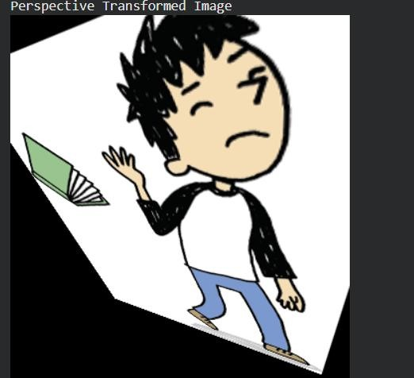
perspective = cv2.warpPerspective(image, M, (cols, rows)) print("Original") cv2_imshow(image) print("Perspective") cv2_imshow(perspective)

RESULT- The program is executed successfully.

EXPERIMENT-13
Aim
To perform perspective transformation on a video using OpenCV.

Algorithm
- Read the video.
- Capture each video frame.
- Define source and destination points.
- Compute the perspective transformation matrix.
- Apply cv2.warpPerspective() to each frame.
- Display the transformed video.
CODE:
import cv2 import numpy as np from google.colab import files from google.colab.patches import cv2_imshow uploaded = files.upload() cap = cv2.VideoCapture("sample.mp4") while cap.isOpened(): ret, frame = cap.read() if not ret: break rows, cols = frame.shape[:2] pts1 = np.float32([[50,50],
[cols-50,50],
[50,rows-50], [cols-50,rows-50]]) pts2 = np.float32([[10,100],
[cols-80,50],
[100,rows-80],
[cols-20,rows-20]])
M = cv2.getPerspectiveTransform(pts1, pts2) output = cv2.warpPerspective(frame, M, (cols, rows)) cv2_imshow(output) input("Press Enter for next frame...") cap.release()
OUTPUT:
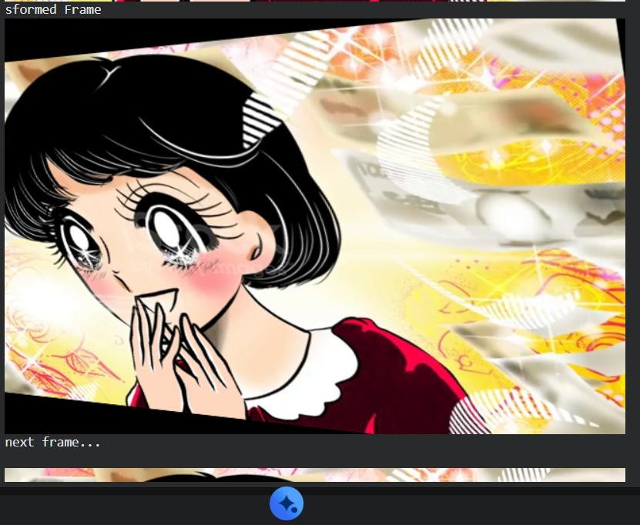
RESULT- The program is executed successfully.

